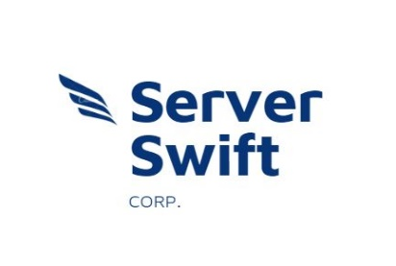

RFP Response for Antoine’s Landscaping

Friday, August 7, 2020

Version 1

Submitted By:

Sina Monajemi

Dauren Bralov

Seohyun Choi

SYS366-NDD

Seneca College

Toronto, Ontario



**Table of Contents**

1. Letter …………………................................................................................3
2. Title Page and Signatures .............................................................................4
3. Summary ……………………………..........................................................5
4. Pricing...........................................................................................................5
5. Vendor description of products and services ................................................6
6. Structure and ownership chart.......................................................................7
7. Target market.................................................................................................
8. Attachments...................................................................................................19

* **Letter**

Dear Mr. Antoine,

Thank you for the opportunity to present this proposal. We appreciate the time you took out of your busy schedule to connect with us. All of us on the Server-Swift team look forward to working with you to implement a state of the art to up-grade your system.

We believe in sharing a very strong sense of partnership. We really focus on providing products and services that meet the unique requirements of our clients. We offer both software and technical services. We have professional services team and staff members with excellent experience.

Our unique abilities, cost effective, and best of market technologies are assets to provide the best customer service and quality support in the industry.

Should you have any questions, please do not hesitate to contact me.

Sincerely,

Our Team

Server-Swift Corp.

* **Title Page and Signatures**

The undersigned agrees to furnish the enclosed items at the price stated, subject to the conditions and requirements of this proposal. The proposal must be signed by someone with the authority to legally bind the Vendor.

System Proposed:

Firm Name:

Address:

1. I/we declare that all answers and statements made in the Proposal are true and correct.
2. Antoine’s Landscaping will not refuse a proposal based upon the use of sub-contractors; however, we retain the right to refuse the sub-contractors you have selected.
3. Unless otherwise required by law, the prices and/or cost data which have been submitted have not been knowingly disclosed by the Proposer and will not knowingly be disclosed by him/her prior to opening, directly or indirectly to any other Proposer or to any competitor.

Signed By: _ _ _ _ _ _ _ _ _ _ _ _ _ _ _ _ _ _ _ _ _

Printed Name:

Title:

Date:

Signature of Proposer: _ _ _ _ _ _ _ _ _ _ _ _ _ _ _ _ _ _ _ _ _

Printed Name:

Title:

Date:

We excel at boosting impressions through our hard work and dedications. We have extensive experience running successful management systems that has helped many landscaping businesses improve and grow their business. We stand out from our competitors by offering products and services that are unique with a reasonable price. We believe in turning moments into memories by offering the best customer service which enables us to better communicate with our clients. We strive in making sure that our systems are user-friendly which can help operations to manage their team from one place. Our company is based in Toronto, Ontario and was founded in 2017, and ever since we have been quite successful with our leads. Our major milestone was in 2019, when we had our first commercial contract which made us who we are now. Dauren Bralov, Seohyun Choi, and Sina Monajemi are on the management team which founded this company. However, our key stakeholder is our creditors and our 10 employees.

We each have a background in Software Programming. We were once classmates who came up with the business idea. We have the skills, work ethic and trust which is our main key to our success.

* **Our mission:**

It is our mission to progressively revolutionize unique services, solve business problems, advance technology and support a young generation.

* **Our vision:**

Our vision is to be recognized and remembered as the leading company in our field.

* **Products & Services**
* Server Swift. Corp has developed a variety of software technologies meant to solve the problems most companies face these days. Server Swift. Corp. aims at managing accounting, financial operations, optimizing operations and increasing software performance. Our team has integrated business processes such as human resources, marketing, eCommerce, inventory management and developing new technology every day!
* Server Swift Corp. offers pricing starts at $29.99 per month. Server Swift Corp. offers customers a free trial. Our company offers the graduates of Seneca College a sale of $5 per month. See additional pricing details below.

------------------------------------------------------------------------------------------------------------

Starting Price $ 29.99/month

$ 24.99/month *for Seneca graduates ----------------------------------------------------------------------------------------------------------------------------*

Free Trial Yes

*------------------------------------------------------------------------------------------------------------------------------*

Training Webinars / Documentation / Online

*Changes applied due to response for covid-19 pandemic*

*------------------------------------------------------------------------------------------------------------------------------*

Support Business Hours

Monday - Friday 9:00 a.m. - 5:00 p.m.

Saturday 10:00 a.m. - 3:00 p.m.

Sunday CLOSED

* **Structure & Ownership Chart**

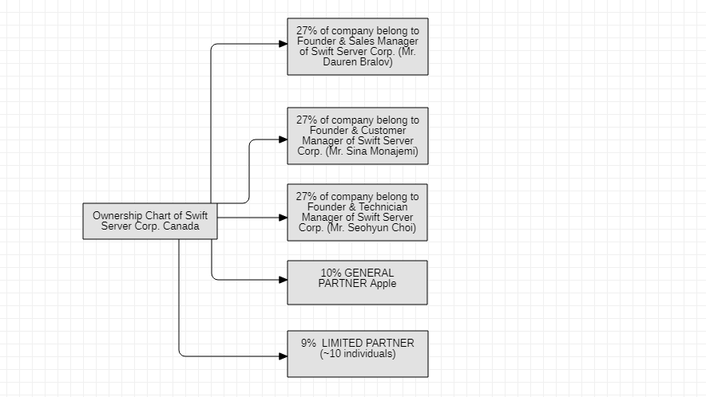

* **Target Market**

Swift Server Corp. Software serves the libraries, museums, colleges, office buildings, retailers, casinos, shopping centers, banks and groceries store. Swift Server Corp. looks forward to collaborate with the Government of Canada to combat the covid-19 pandemic and provide the required software to support the well-being of Canadian Citizens.



* **Location**

*320 Bay Street, M5H 4A6, Toronto, ON, Canada. Phone number: +1-647-228-31-24*